9.Network graph – Supplementary
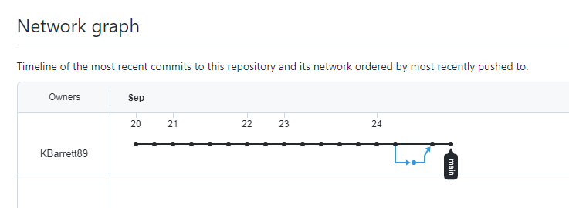

10.Network graph – NGINX
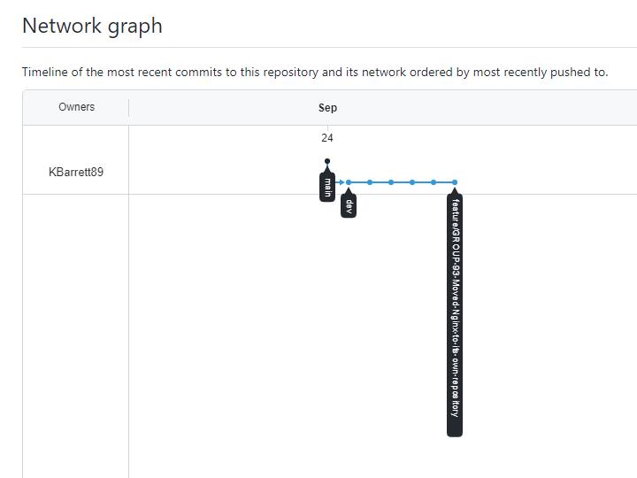

11,12,13.MERGE requests
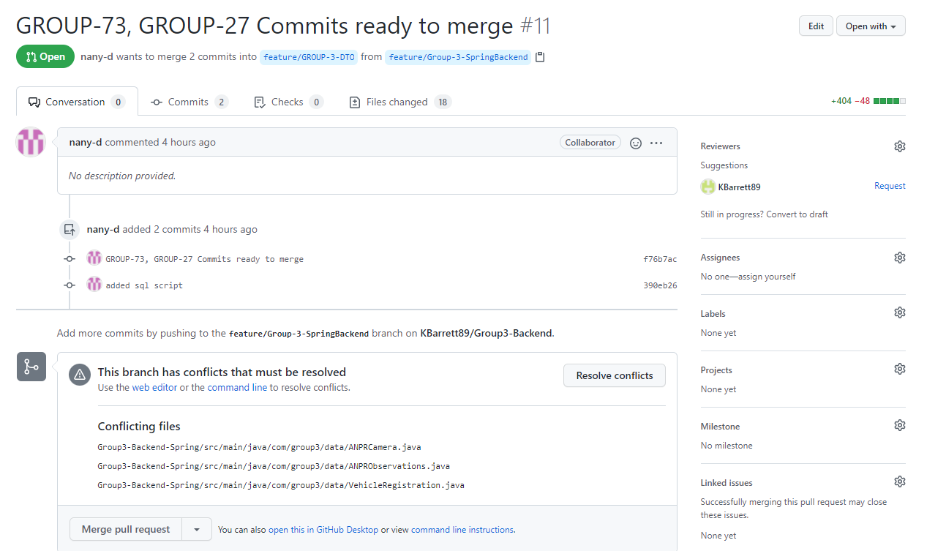

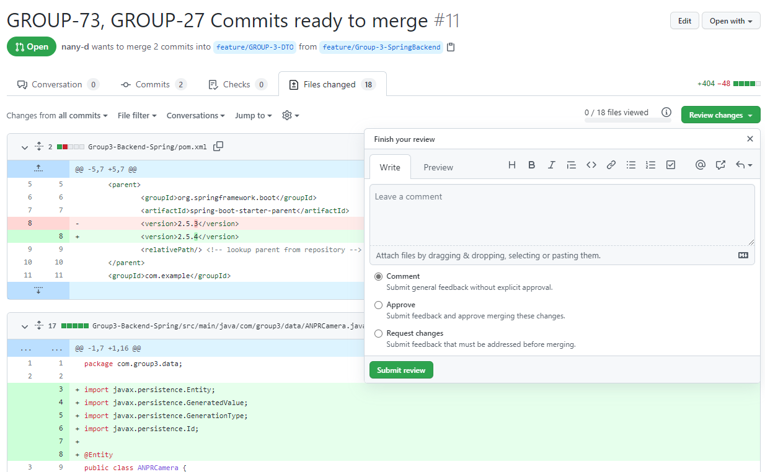

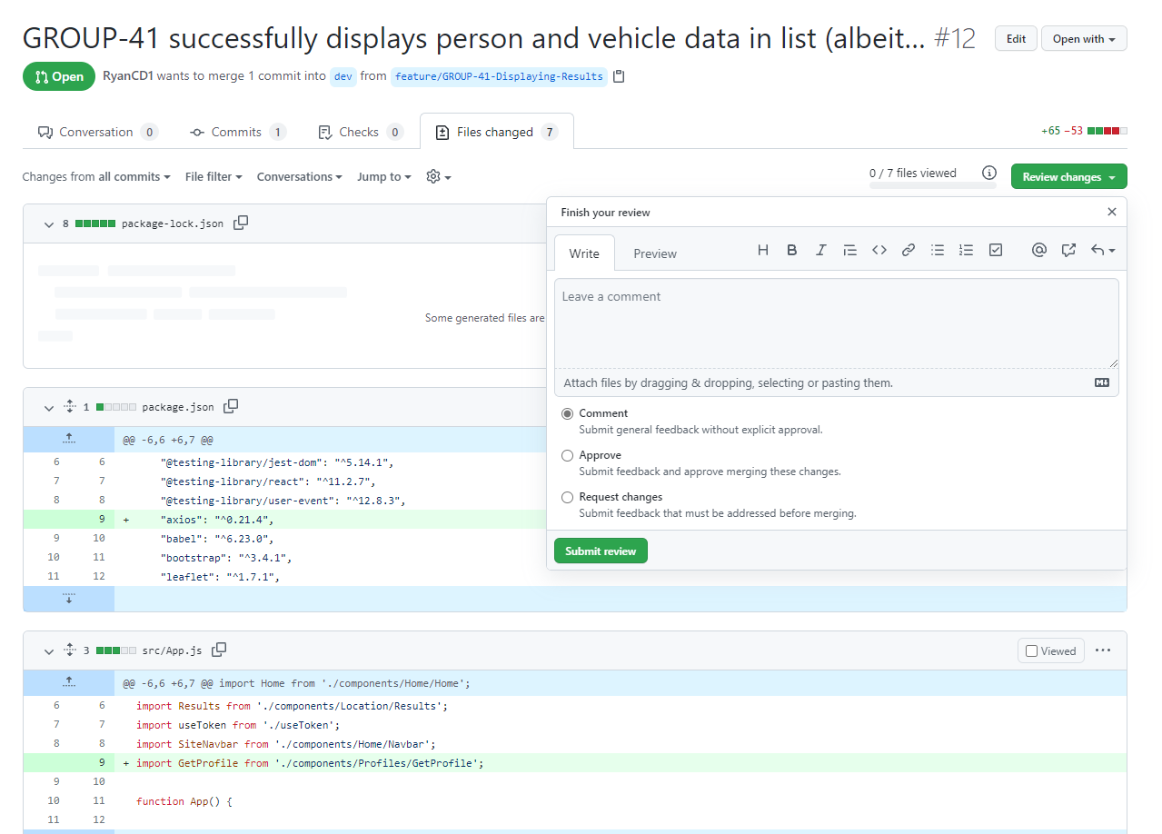

14.table/data structure
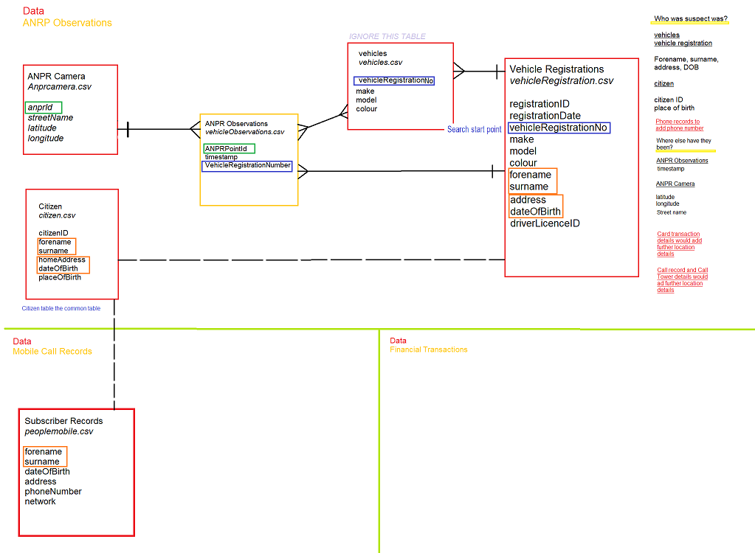

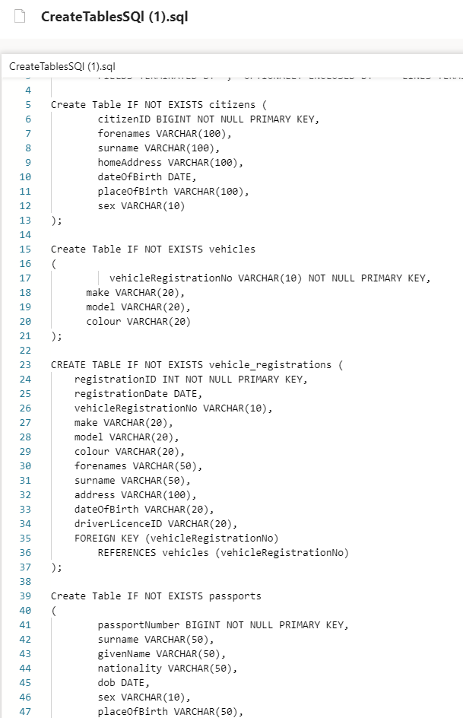

15.Create Tables SQL

